Running the Simulation

The Organ Bath simulation program allows you to perform simulated in vitro experiments on two different types of contractile tissue – the chick biventer cervicis skeletal muscle or the guinea pig ileum smooth muscle preparation.

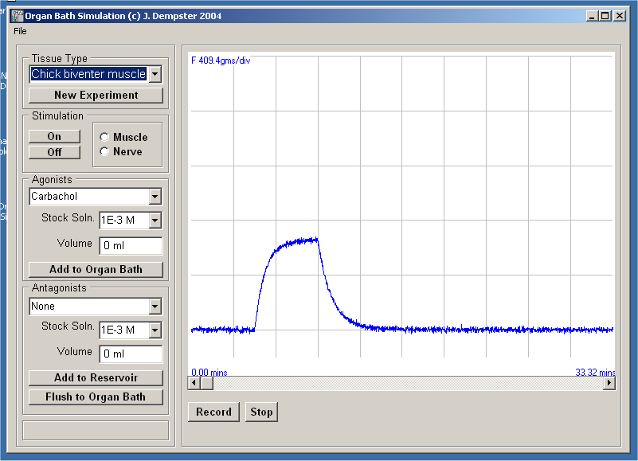
To start the Organ Bath simulation program click on its icon in the Phys & Pharm folder on the Windows desktop.
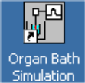

Starting an experiment

To start a simulated experiment:

- Select the type of tissue you intend to experiment from the Tissue Type list (Chick biventer or Guinea pig ileum).
- Click the New Experiment button to clear the chart display.
- Click the Record button to start recording the tissue contractile force in the chart recorder window.

Note. Do not change the tissue type during the course of an experiment. You can also stop and re-start recording at any time using the Stop / Record buttons.

Applying agonists

Agonists are injected directly in to the organ bath which has a volume of 10 ml.

To apply an agonist:

- Select the type of agonist to apply from the Agonist list.
- Select the concentration of the agonist stock solution to be added from the Stock Soln. list.
- Enter the volume (0-1 ml) of stock solution to be added into the Volume box.
- Click the Add to Organ Bath button.
- Wait till the tissue response is observed.
- Click the Flush Tissue Bath to remove the agonist. (Note. The bath is flushed with solution from the reservoir.)

Applying antagonists

Antagonists are added to the reservoir (which has a volume of 1000 ml) and applied to the tissue in the organ bath by flushing from the reservoir. This allows agonists to be added and washed out while maintaining a constant concentration of antagonist in the bath.

To apply an antagonist

- Select the type of antagonist to apply from the Antgonist list.
- Select the concentration of the antonist stock solution to be added from the Stock Soln. list.
- Enter the volume (0-1 ml) of stock solution to be added into the Volume box.
- Click the Flush Tissue Bath button to add the antagonist.

